AERS TRANSFORM

Week 16 Final ERI Employability Passport and Progression Plan Pack
Human Approved Programme Closure v2.0
Final Evidence Conference | Passport Release | 30 60 90 Day Plan

Programme owner ASV Education Pvt. Ltd.
Authorised representative Mounesh CP AERS Facilitator
Understand First. Improve with Evidence.

Purpose and approved outcome
Week 16 closes the AERS Transform learner journey through a human-led final evidence conference. Authorised reviewers interpret the evidence available at baseline, midpoint and programme close; approve the final ERI profile; validate the Employability Passport; confirm the evidence portfolio; and approve a practical 30 60 90 Day Progression Plan. The output is a transparent readiness profile, not an employment certificate or guarantee.
Control | Approved value
Document ID | AERS-W16-EPP-002
Version | v2.0
Programme position | Week 16 of 16
Entry evidence | Authorised Week 15 handover plus six module-close decisions
Readiness structure | Seven evidence domains; domain status and limitations shown
Public Passport labels | Verified; Developing; Evidence Pending
Human authority | Authorised reviewer approves final ERI profile, corrections, referrals and Passport release
Numeric ERI rule | Display only when an approved, versioned calculation method is formally configured; otherwise publish the domain profile
Final outputs | Final ERI Profile; Employability Passport; closed evidence portfolio; 30 60 90 Day Progression Plan
Programme decision | Completed; Completed with continuing development; Conditional completion; or Hold and review

Seven ERI evidence domains
Domain | Primary evidence basis
Career clarity and direction | Career direction, role research and approved action plan
Résumé and professional profile | Verified résumé, claim-to-evidence mapping and professional profile
Communication | Introduction, workplace communication, listening, discussion and presentation evidence
Aptitude and problem solving | Controlled practice, reasoning, error analysis and improvement evidence
Workplace readiness and behaviour | Scenario responses, professional judgement, teamwork, ownership and responsible conduct
Interview and selection performance | Role preparation, structured responses, final interview and employer simulation
Learning ownership and evidence integrity | Completion, feedback application, revision discipline, authenticity and Responsible-AI declarations

Final authority boundary
Technology may calculate approved values, display statuses, generate a draft Passport and preserve the audit trail. It cannot independently validate evidence, resolve a hold, change a readiness claim, approve the final ERI profile or release the Employability Passport. AERS-authorised human approval remains mandatory.

Week 16 operating sequence
Stage | Activity | Required output | Decision owner
1 Release check | Validate Week 15 handover, module decisions, consent, privacy and open actions. | Completion readiness record | Authorised reviewer
2 ERI review | Compare baseline, midpoint and final evidence across seven domains. | Final ERI evidence and interpretation record | Reviewer and moderator
3 Passport validation | Check identity, domain statuses, evidence links, limitations and sharing controls. | Validated Passport draft | Learner and authorised reviewer
4 Portfolio closure | Confirm final versions, permissions, retention and unresolved items. | Portfolio closure register | Facilitator or evidence custodian
5 Final conference | Explain results, limitations, corrections, referral and appeal route. | Conference decision and acknowledgement | Learner, reviewer and institution
6 Progression planning | Approve specific 30, 60 and 90-day actions, evidence and review dates. | Approved Progression Plan | Learner and facilitator
7 Release and closure | Record programme decision and authorise or withhold Passport release. | Release record and programme closure | Authorised AERS reviewer

Status meanings
Public status | Meaning | Use rule
Verified | The learner has demonstrated the capability through acceptable evidence reviewed by an authorised human. | Name the evidence, conditions, date and reviewer.
Developing | Evidence shows progress, but the capability needs continuing practice, consistency or broader demonstration. | Name the observed strength and next action.
Evidence Pending | Available evidence is missing, incomplete, unresolved or not yet sufficient for a supported claim. | Do not infer readiness; name the missing evidence or hold.
Internal workflow may also use Hold and Review or Not Assessed. These are control states and must not be misrepresented publicly as verified capability.

Interpretation principle
Progress and present readiness are related but different. A learner may improve substantially and still remain Developing in a domain. A learner may also be Verified under recorded conditions while retaining a continuing-development priority. Each conclusion must remain traceable to evidence and limitations.

AERS TRANSFORM v2.0
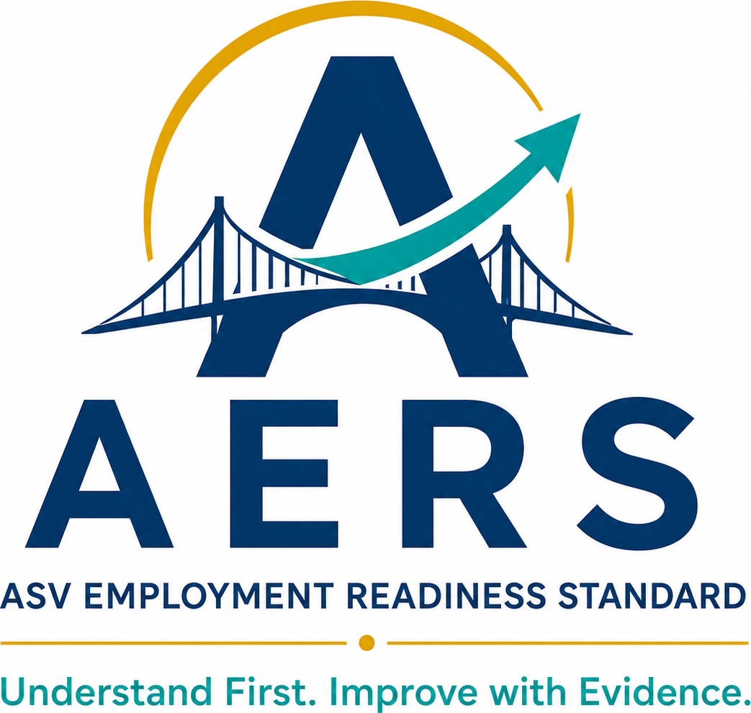

Week 16 Final ERI Employability Passport and 30 60 90 Day Progression Plan Pack
  - Final ERI, Employability Passport and 30 60 90 Day Progression Plan
Programme Completion
Duration | Completion Result | Required Deliverable
Week 16 | Final readiness understood and post-programme improvement committed | Final ERI + Employability Passport + Portfolio + 30/60/90-Day Plan

Understand First. Improve with Evidence.
Prepared by ASV Education Pvt. Ltd. | Mounesh CP, AERS Facilitator

1. Week 16 Outcome and Completion Standard
Week 16 closes the programme through a final evidence conference. The learner interprets the final Employment Readiness Index (ERI), validates the Employability Passport, confirms the portfolio and commits to a 30/60/90-day progression plan. Completion is evidence-based, transparent and actionable—not an employment guarantee.
Outcome | Required Evidence | Completion Standard
Final readiness | Baseline/midpoint/final ERI record | Capability results linked to valid evidence and limitations
Verified profile | Employability Passport | Learner details and readiness claims checked and acknowledged
Evidence ownership | Final portfolio register | Required artefacts accessible, versioned and permission-controlled
Progression | 30/60/90-day plan | Specific actions, evidence, owners/support and review dates
Completion | Human-led conference decision | Outcome, referral and learner/institution acknowledgement recorded

Weekly time plan
Component | Time | Mode
Final ERI review | 45 min | Platform/guided
Passport validation | 45 min | Learner/facilitator
Portfolio closure | 30 min | Evidence review
Final evidence conference | 45 min | Learner/institution
Progression plan and acknowledgement | 45 min | Guided

2. Completion Principles and Safeguards
Principle | Required Practice
Evidence before claim | Every readiness statement cites a verified artefact, score or observation.
Transparent interpretation | Explain what the ERI and Passport show, do not show and when evidence was current.
No employment guarantee | Completion/readiness does not promise placement, interview or employment.
Learner participation | Learner reviews identity, evidence, limitations and next actions before release.
Privacy and consent | Share only authorised fields for a stated purpose; protect confidential evidence.
Human accountability | Qualified reviewers approve final results, corrections, referrals and release.

Responsible-AI boundary
- AI may assist permitted drafting or interpretation when declared and human-checked.
- AI cannot fabricate evidence, impersonate the learner, decide readiness or expose confidential data.
- AI-generated wording never upgrades an unsupported capability claim.

3. Week 15 Handover and Completion Readiness
Week 15 Input | Status / Reference | Completion Action
Final interview rubric
Independent panel notes/decision
Employer simulation rubric
Learner reflection/AI declaration
Verified evidence set
Continuing-development recommendation
Re-attempt or hold decision
Final ERI evidence readiness
Passport evidence readiness

Completion readiness: □ Ready for final conference □ Conditional action □ Hold/review

4. Final ERI Evidence Inventory
Capability Domain | Baseline Evidence | Midpoint Evidence | Final Evidence | Verification
Career clarity/direction
Resume/professional profile
Communication
Aptitude/problem solving
Interview/selection performance
Workplace readiness/behaviour
Learning ownership/evidence integrity

Inventory checks
□ Dates/versions recorded □ Approved rubrics used □ Missing evidence identified □ Support conditions visible □ Integrity holds resolved

5. Baseline–Midpoint–Final ERI Comparison
Domain | Baseline Result | Midpoint Result | Final Result | Change / Evidence Interpretation
Career clarity
Resume/profile
Communication
Aptitude
Interview readiness
Workplace readiness
Overall ERI (approved method)

Interpretation safeguards
- Use the approved ERI method consistently across all three points.
- Do not average unrelated evidence or fill missing data with assumptions.
- Improvement and current readiness are related but distinct conclusions.
- State when conditions, task versions or support affect comparability.

6. Final ERI Interpretation Record
Interpretation Field | Human-Reviewed Record
Final ERI result/date/version
Highest verified readiness strengths
Most material continuing-development needs
Baseline-to-final improvement summary
Evidence limitations/missing information
Accessibility/language conditions relevant to interpretation
Integrity/moderation note
Recommended progression pathway
Reviewer rationale

Readiness wording
Use: “Evidence indicates…” or “Verified under recorded conditions…”. Avoid: “Guaranteed job-ready,” “will be placed,” or claims beyond the verified evidence.

7. Employability Passport — Identity and Scope
Passport Field | Validated Entry
Learner name / unique ID
Institution/programme/qualification
Academic status/completion year
Career preference / target role family
AERS Transform participation dates
Passport issue date/version
Final ERI reference
Portfolio/evidence reference
Authorised issuer/reviewer
Learner sharing consent/scope

Passport statement
The AERS Employability Passport summarises verified readiness evidence available on the issue date. It is not a degree, licence, job offer or employment guarantee. Employers and institutions retain their own eligibility and selection decisions.

8. Employability Passport — Capability Summary
Capability | Status | Verified Evidence Reference | Limit / Next Action
Career clarity
Verified resume/profile
Professional communication
Aptitude/problem solving
Interview readiness
Workplace readiness
Learning ownership/integrity

Status options: Verified / Developing / Evidence Pending / Internal Hold or Not Assessed. Use only the status supported by the approved evidence.

9. Employability Passport — Evidence and Achievement Register
Evidence / Achievement | Learner Contribution | Verification Source | Date / Version | Sharing Status
Project/capstone
Internship/work exposure
Certification/assessment
Achievement/recognition
Final verified resume
Aptitude report
Communication portfolio
Final interview/simulation

Sharing status
Internal only / Learner-approved external sharing / Restricted confidential evidence / Verification pending.

10. Passport Validation and Correction Log
Validation Check | Learner Decision | Reviewer Action
Identity/academic details accurate
Career preference is current
ERI result/reference accurate
Capability statuses follow evidence
Resume and portfolio versions correct
Projects/contribution described truthfully
Limitations/next actions visible
Consent and sharing scope understood

Correction record
Field | Original Entry | Corrected Entry | Evidence / Approver

11. Final Portfolio Closure Register
Portfolio Item | Final Version / Location | Verified? | Access / Retention Note
Career Capability Portfolio
Verified Resume/Profile
Communication Confidence Portfolio
Aptitude evidence/report
Interview evidence bank
Workplace-readiness evidence
Week 14 comparative improvement record
Week 15 final simulation evidence
Final ERI and Passport
30/60/90-day progression plan

Closure does not require deleting drafts needed for audit. Retain or dispose of records according to authorised policy and consent.

12. Final Evidence Conference
Conference Stage | Facilitator / Reviewer Action | Learner Action | Record
Readiness overview | Explain final ERI and evidence | Confirm understanding/questions | Conference note
Passport review | Explain statuses, limits and sharing | Validate/correct details | Passport decision
Strengths/gaps | Link claims to verified evidence | Reflect on capability and support | Priority summary
Progression | Agree realistic next actions/referrals | Commit actions and evidence | 30/60/90 plan
Closure | Confirm outcome and appeal/correction route | Acknowledge decision | Completion record

Conference summary
Prompt | Summary
Learner’s strongest verified readiness evidence
Most important continuing-development need
Learner question/disagreement/correction
Referral or institution support agreed
Release/sharing decision

13. 30 60 90 Day Progression Plan
Period | Priority Outcome | Actions | Evidence of Progress | Support / Review
Days 1–30
Days 31–60
Days 61–90

Required action areas
Area | Selected Action / Target
Career applications/networking
Resume/profile maintenance
Communication/interview practice
Aptitude/technical capability
Project/workplace evidence
Wellbeing, access or specialist support

14. Referral and Continuing-Development Record
Unresolved Critical Gap | Risk / Impact | Referral / Support | Owner | Review Date

Referral safeguards
- Explain the reason, purpose, consent and expected next step.
- Do not diagnose needs outside the facilitator’s competence.
- Escalate safeguarding, integrity, privacy or accessibility issues through authorised procedures.
- A continuing-development recommendation is not programme failure; it makes the next step explicit.
Post-Programme Status | Decision
Critical gap resolved | Yes / No / Not applicable
Continued development required | Yes / No
Referral accepted by learner | Yes / No / Pending
Institution follow-up agreed | Yes / No / Not applicable

15. Completion Decision, Acknowledgement and Release
Completion Dimension | Evidence / Finding | Decision
Programme participation/evidence |  | Complete / Conditional / Incomplete
Final ERI validity |  | Valid / Conditional / Hold
Employability Passport |  | Release / Correct / Hold
Portfolio closure |  | Complete / Action required
Progression plan |  | Committed / Revise
Critical referral |  | None / Active / Hold
Overall completion |  | Evidence-based completion / Continuing development / Hold

Acknowledgement
I understand the final ERI and Employability Passport reflect verified evidence available under recorded conditions. They do not guarantee employment. I have reviewed corrections, limitations, sharing consent and my progression actions.
Learner: __________________ Facilitator/reviewer: __________________ Institution representative: __________________ Date: __________
Correction/appeal route explained: □ Yes Passport release authorised: □ Yes □ Conditional □ No

16. Programme Completion and Institutional Review
Final Deliverable | Status | Reference / Required Action
Final ERI interpretation | Complete / Conditional / Missing
Employability Passport | Complete / Conditional / Missing
Verified portfolio | Complete / Conditional / Missing
30/60/90-day progression plan | Complete / Conditional / Missing
Final evidence conference | Complete / Conditional / Missing
Referral/continued-development record | Complete / Conditional / Missing
Learner acknowledgement | Complete / Conditional / Missing
Institution completion record | Complete / Conditional / Missing

Institutional observation
Review Question | Finding / Recommendation
Is the final readiness report understandable and useful for progression decisions?
Can every Passport claim be traced to verified evidence?
Are limitations and no-employment-guarantee wording clear?
Is the progression/referral plan practical after programme completion?
What should be retained, changed, added or removed for the institutional version?

Final programme decision: □ Completed □ Completed with continuing development □ Conditional completion □ Hold/review
Authorised by: ______________________________ Role: __________________ Date: __________
Document control: Week 16 Final ERI Employability Passport and 30 60 90 Day Progression Plan Pack v2.0. This closes the AERS Transform v2.0 16-week learner delivery sequence and preserves evidence for authorised reporting, improvement and progression.

Week 16 v2.0 Programme Closure Annexes
These annexes establish the current seven-domain ERI profile, the public-facing Employability Passport record, release approval and post-programme progression controls. They supplement the complete Week 16 delivery forms retained above.

Final ERI Domain Decision Register
Domain | Baseline evidence | Midpoint evidence | Final evidence | Status | Limitations and next action
Career clarity and direction
Résumé and professional profile
Communication
Aptitude and problem solving
Workplace readiness and behaviour
Interview and selection performance
Learning ownership and evidence integrity
Permitted public status: Verified, Developing or Evidence Pending. Internal Hold and Review must block public release until resolved or explicitly excluded with authorised reasoning.

Final ERI Profile Approval
Approval field | Record
Approved ERI method and version
Numeric ERI displayed | Yes / No
If yes, approved calculation reference
Evidence cut-off date
Domains with Verified status
Domains with Developing status
Domains with Evidence Pending status
Unresolved hold or limitation
Overall interpretation statement
Moderation completed by and date
Authorised approval by and date
Approval rule: do not create, infer or publish a numeric index unless the governing calculation, weights, thresholds and moderation rules have been formally approved and versioned.

Employability Passport Master Record
Passport field | Approved entry
Passport ID and version
Learner name and approved identifier
Institution, programme and cohort
Issue date and evidence cut-off date
Target role or career direction
Verified capabilities
Developing capabilities
Evidence Pending capabilities
Key evidence links or references
Human reviewer and verification date
Sharing permission | Internal only / Learner-approved external sharing / Restricted
Expiry, review or update date if applicable
Verification route or contact
Passport statement: This Passport summarises evidence reviewed under recorded AERS conditions as of the issue date. It is not a degree, licence, job offer, background check or employment guarantee. Recipients should review the stated evidence, context and limitations.

Passport Claim and Evidence Register
Capability claim | Public status | Evidence reference | Conditions or limitations | Reviewer and date

Passport Validation and Release Checklist
☐ Learner identity and institution/cohort are correct
☐ Seven domain statuses match the approved ERI decision register
☐ Every Verified claim links to acceptable human-reviewed evidence
☐ Developing statuses name a continuing action
☐ Evidence Pending statuses do not imply readiness
☐ Evidence dates, versions and reviewers are traceable
☐ Confidential evidence is not exposed through public links
☐ Learner sharing consent and scope are recorded
☐ Correction and appeal route has been explained
☐ No unresolved authenticity, privacy, consent, safety or factual hold
☐ Authorised AERS reviewer has approved release
Passport release decision: ☐ Approved ☐ Conditional with named action ☐ Withheld
Authorised reviewer: ____________________ Role: ____________________ Date: __________

Evidence Portfolio Closure Index
Evidence category | Final item and version | Access or sharing status | Retention or review action
Career direction and plans
Résumé and professional profile
Communication evidence
Aptitude and problem-solving evidence
Workplace-readiness evidence
Interview and final demonstration evidence
Feedback, revisions and acknowledgements
Responsible-AI and authenticity declarations
ERI and Passport approval records

Final Evidence Conference Record
Conference field | Record
Date, time and mode
Learner
Authorised reviewer
Facilitator
Institution representative if present
Final ERI profile explained | Yes / No
Passport fields and sharing controls validated | Yes / No
Limitations and Evidence Pending items explained | Yes / No
Corrections or appeal route explained | Yes / No
Referral or continuing-development support
Learner questions and response
Conference decision

Approved 30 60 90 Day Progression Plan
Period | Priority outcome | Specific actions | Evidence of completion | Support or owner | Review date
First 30 days
By 60 days
By 90 days

Progression Plan Quality Check
☐ Each action is linked to a verified need or career goal
☐ The learner can control or influence the action
☐ Evidence of completion is observable
☐ Support, resource or referral is named
☐ Review dates are realistic
☐ Fallback action is recorded for likely barriers
☐ Plan does not imply guaranteed placement or employment

Learner Commitment and Acknowledgement
I have reviewed my final ERI profile, Employability Passport, evidence portfolio and 30 60 90 Day Progression Plan. I understand which capabilities are Verified, Developing or Evidence Pending and the evidence and limitations supporting those decisions. I understand that these records do not guarantee employment. I will complete the agreed actions honestly, protect confidential information and continue to declare material AI assistance where relevant.
My first 30-day commitment is ____________________. I will demonstrate completion through ____________________ by ____________________.
Learner name and signature: ____________________ Date: __________
Facilitator or reviewer acknowledgement: ____________________ Date: __________

Programme Completion and Release Record
Closure component | Complete | Conditional | Hold | Action or reference
Week 15 handover accepted | ☐ | ☐ | ☐
Final ERI profile approved | ☐ | ☐ | ☐
Employability Passport validated | ☐ | ☐ | ☐
Evidence portfolio closed | ☐ | ☐ | ☐
30 60 90 Day Progression Plan approved | ☐ | ☐ | ☐
Learner acknowledgement recorded | ☐ | ☐ | ☐
Institution completion record prepared | ☐ | ☐ | ☐
Consent, privacy and sharing controls confirmed | ☐ | ☐ | ☐
Final programme decision: ☐ Completed ☐ Completed with continuing development ☐ Conditional completion ☐ Hold and review
Passport release: ☐ Released ☐ Conditional release ☐ Withheld
Authorised by: ____________________ Role: ____________________ Date: __________

Platform Status and Audit Controls
Status | Meaning | Required platform control
Week 16 Review Pending | Final conference records are incomplete. | Block Passport release.
ERI Under Review | Evidence profile is being interpreted or moderated. | Preserve versions and restrict decision access.
Correction Required | Identity, evidence, status or wording needs correction. | Route correction and retain history.
ERI Approved | Authorised reviewer approved the final profile. | Record approver, method version and timestamp.
Passport Draft | System-generated draft awaits validation. | Do not expose externally.
Passport Release Approved | All release conditions are satisfied. | Publish approved version and verification route.
Conditional Completion | Named action remains but authorised completion conditions are documented. | Display limitation and deadline.
Hold and Review | Material integrity, privacy, consent, safety, fairness or evidence issue. | Block release and escalate.
Programme Closed | Final records and acknowledgements are complete. | Set records read-only except governed correction or appeal.

Version Control and Approval
Field | Record
Version | v2.0
Regeneration date | 17 September 2026
Content basis | Approved Week 16 Final ERI, Employability Passport and Progression Plan Delivery Pack v1.0 plus revised six-module and Week 15 architecture
Primary change | Seven-domain profile, approved public status labels, controlled numeric ERI rule, Passport release checklist and programme-closure controls
Decision authority | Authorised human reviewer and moderator
Final output | Approved ERI Profile, Employability Passport, evidence portfolio and 30 60 90 Day Progression Plan
Change control | Changes to domains, status labels, ERI method, Passport claims, eligibility or release rules require a new approved version
Prepared or facilitated by: Mounesh CP ____________________ Date: __________
Programme approval: ______________________________________ Date: __________
Institution acknowledgement: ______________________________ Date: __________

